Annual Report of World Geopark Network- Geopark 2020

1．Park Identity
Geopark name, national and regional network:
Jingpohu UNESCO World Geopark, China, Asia-Pacific Geopark Network
Year of accession / year of last reassessment
2006/2018
Representative photo (most important event of the year)
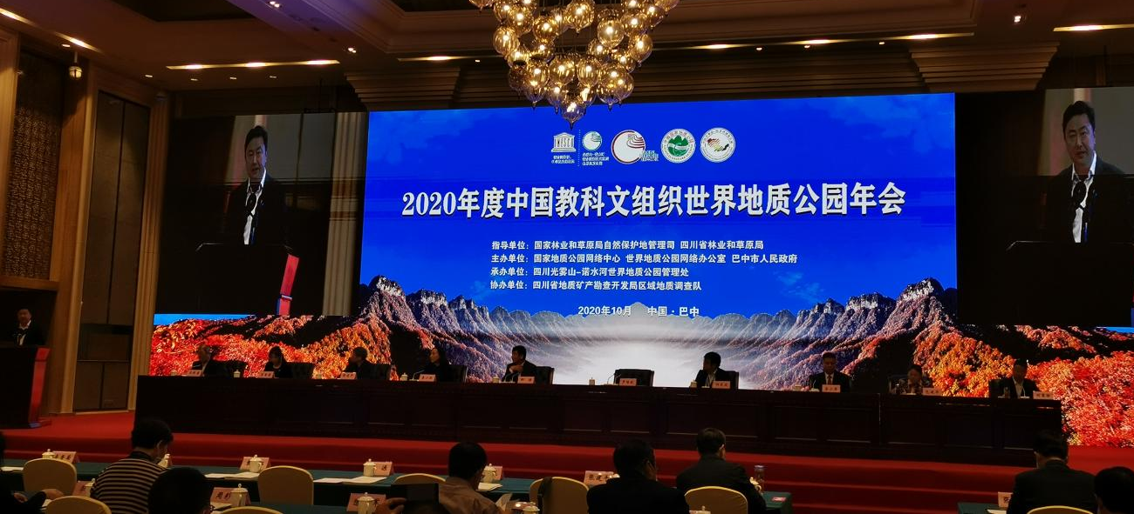
Participated the 2020 China World Geopark Annual Work Conference
2. Geopark Data
Employees: 462 staff including 2 geologists
Number of visitors: 212,000
Number of Geopark Activities: 5
“Jingpohu World Geopark Popular Science Lecture”, “Earth Protection from us” Popular Science Publicity Week, conduct geopark popular science knowledge lecture in underground forest scenic spot on “April 22 Earth Day”, conduct geological knowledge publicity to citizens on “ May 19 China Tourism Day”, conduct environment protection knowledge publicity on June 5 World Environment Day.
Number of school classes with Geopark Education Program:
Total 20 classes in 4 schools including Mudanjiang No. 9 Middle School, No. 11 Middle School, No. 4 Middle School, and Dongjing Town Middle School.
Number of Geopark press released: release 2 reports in traditional media of province and city above level, 178 reports in internet and new media.
- Geopark Activities (itemized)
Key Achievements in 2020
- Push the restart of Jingpohu Library and affiliated facility construction project;
- Complete the repair work of water damaged roads and foundation facility in Diaoshuilou waterfall area and Jingpohu northern gate area;
- Plant 50,000 plants, 40,000 root flowers, 3,600 arbors and bushes, 1000 square meters grass, and re planted 100 landscape trees;
- Complete upgrading of wisdom scenic spot current platform software and hardware equipment and facility and maintenance and repair of the point break circuit;
- The management committee reinforces the management of the geopark, conduct total 271 patrols and releases 3 shut down notification;
- Implement “lake leader responsibility system” completely, established Jingpohu management committee 3 layers lake leaders system to definite the functions, responsibilities and management scope, develop the work system;
- Conduct Jingpohu pollution prevention.
Contribution to GCN – network activity and participation
- Remit to UGG an annual fee of 1500 euros for 2020.
- Participate “2020 China World Geopark Annual Conference and Experience Communication Meeting”.
- Host “The 3rd China Volcano Geopark Forum 2020” together with Yandangshan, Leiqiong, Wudalianchi, Ningde World Geopark.
Management and Financial Situation
Management Organization: Jingpohu World Geopark Management Committee
Financial Situation: financial situation is good, 2020 tickets income is 10.13 million RMB.
Protection of geological monuments
- Push the implementation of “Lake Leader System”, and focus on improving Jingpohu water ecosystem.
- Invest on geological monuments protection and recovery against the summer season continuous flood damage.
- Conduct whole year patrols in the open air, forest fire protection and community publicity.
- Set up popular science promenade in the scenic area of villa, crater sub-sect area, waterfall village, Xiaozhu Village, Dongjing Town Middle School etc, to propagate the knowledge of protection of geological relic.
- According to the emergency plan of geological relic protection, ecology protection and forest fire protection, conduct 4 combined inspections, 4 resources protection trainings and exercises.
Sustainable tourism (geological tourism)
Receive visitor of 212,000 with geological tourism income of 56.53 million RMB. There are 14 home-stays and 79 restaurant and inns with direct employees of more than 3100 and indirect beneficiary of more than 6000.
New Educational Programs on Geological Heritages Protection, Sustainable Development and Disaster Risk Reduction
Formulate “Jingpohu World Geopark Geological Science Popularization Publicity and Education Activity Plan” to conduct geological heritage protection, ecology protection education to the whole city teenagers, and conduct activities like “April 22 World Earth Day”, “International Biodiversity Day”, “June World Environment Day”, “International Day for Natural Disaster Reduction”.
Work with Mudanjiang Normal College on “scenic spot and college cooperation” to sign agreement on science popularization education base and set up promenade in the college. Cooperate with Mudanjiang No. 11 Middle School, No. 9 Middle School, No.4 Middle School, Dongjing Town Middle School, Orchid Chin School, and Ang Li Foreign Language School, etc. to conduct geological science popularization lecture and educational tour activities. In the activity of “Build Beautiful Village” in Ning’an Xiaozhu Village Community, conduct geopark environment protection science popularization education and natural disaster reduction education.
Strategic Partners
Work with Heilongjiang Provincial Institute of Hydrogeology and Engineering Geology on geology study and protection; cooperate with China University of Geosciences (Wuhan), School of Geography of Beijing Normal University, Mudanjiang Normal College, Ning’an Dongjing Town Middle School to set up “science popularization education base”; build “beautiful village” with Ning’an Xiaozhu Village community; conduct geological tourism with more than 100 travel agencies like Ctrip, CYTS, Northeast Scenic Spots Alliance, Top 100 Travel Agencies, etc.; cooperate with Heilongjiang Provincial Culture And Tourism Office, Mudanjiang Municipal Propaganda Department, Mudanjiang City Culture，Broadcasting And Tourism Bureau, Mudanjiang News Media Group, 18 main internet media and 5 we media on geopark internet publicity.
Conduct 3 times total 6 live streaming on CCTV 2 and CCTV 13, Shenzhen TV shoot and broadcast science popularization film of “secret of round waterfall”.
Use the platform built by municipal propaganda department, conduct one year full popularization activity with “Toutiao” and Heilongjiang Radio and Media Co. Ltd.
Promotional Activities
Organize summer season tourism product sharing meeting, tourism promotion convention and key distributor forum in Harbin, Beijing, Shanghai and Guangzhou; participate kickoff activity of “Northeast, Yangtze River Delta boutique scenic spot group direct purchasing platform” which is organized by Northeast Scenic Spot Alliance and Yangtze River Delta Scenic Spot Alliance and “Haikou Scenic Spot Committee and Northeast Scenic Spot Alliance, Yangtze River Delta Scenic Spot Alliance communication meeting on mutual tourist market and tourism cultural product”; participate “2020 China Tourism Industry Expo and No. 25 China North Tourism Trade Fair”; participate National 5 Key Summer Season Travel Cities Promotion Meeting organized by Heilongjiang Provincial Culture And Tourism Office, and Beijing Tourism Promotion Conference organized by Mudanjiang City Culture，Broadcasting And Tourism Bureau; participate the “Spring in North and Travel in Heilongjiang”, “Summer Resort, Travel in Heilongjiang” theme promotion meeting organized by Heilongjiang East Travel Alliance in Shenyang; participate “Mudanjiang Winter Season Travel Promotion Meeting” organized by Mudanjiang City Culture，Broadcasting And Tourism Bureau in Dongguang; participate 3rd Heilongjiang Tourism Development Conference and apply the 4th conference successfully; participate “Just Go” Guangzhou local promotion activity organized by Guangdong TV.
4. Contact
Administrator: Dongjun Li jphzpg@163.com
Geologists: Jiangfeng Li, Xuewu Zhou jfli0524@163.com

